Solar-powered adaptive battery charger for IoT solutions using ESP32

Elias Prudencio Chavez Jaldin
Department of Electronics and Bioengineering
Universidad Privada del Valle
Cochabamba, Bolivia echavezj@univalle.edu https://orcid.org/0000-0003-0053-606X
Eynar Calle Viles
Research Department
Universidad Privada del Valle
Cochabamba, Bolivia
ecallevi@univalle.edu
https://orcid.org/0000-0003-1477-2813

Edgar Roberto Ramos Silvestre
Department of Electronics and Bioengineering
Universidad Privada del Valle
Cochabamba, Bolivia
eramoss@univalle.edu
https://orcid.org/0000-0001-7583-5852

Abstract— The growth of Internet of Things (IoT) applications has intensified the demand for energy-autonomous devices, highlighting the limitations of conventional chargers. The paper addresses the design of a charging system for rechargeable batteries -including Li-ion, LiPo, NiCd and lead-acid- oriented to energy autonomous contexts using solar energy. An analysis of existing charging methods (Constant Current - Constant Voltage, step charging and pulsed charging), and their limitations when applied to multiple battery types in IoT environments is performed. A system based on an adaptive charging Current algorithm similar to step charging, managed by the ESP32 development board and powered by an 80 W solar panel is proposed. The system allows setting the maximum charging voltage and dynamically regulates the current depending on the battery status, with two thresholds (450 mA and 2000 mA), integrating temperature and humidity sensors, data storage in microSD and Bluetooth communication for monitoring and control. The test included the analysis of the thermal and electrical behavior of a lead-acid battery (12 V, 7 Ah) under stable and variable solar irradiation conditions, demonstrating operational stability, current regulation and absence of overheating. Additionally, tests were carried out with Li-Ion, LiPo and NiCd batteries, showing stable behavior and capacity under stable and variable solar irradiation conditions.
Keywords—Solar Energy, Battery Charging, Adaptive Charging, ESP32, IoT Solutions, Smart Charger, Embedded Systems

Introduction
Technological developments in the fields of energy storage and renewable energy generation have led to significant advances in powering electronic devices, particularly in environments where efficiency, sustainability and energy autonomy are essential. In this context, rechargeable batteries play a central role, especially in applications related to the Internet of Things (IoT), where a balance between efficiency, adaptability and autonomy is required.
This paper presents a synthesis of the main types of rechargeable batteries, their technical characteristics, most common applications and the mechanisms that affect their efficiency and useful life. It also discusses the opportunities offered by solar energy through photovoltaic cells and their importance in the transition to sustainable energy models.
One of the persistent challenges in this area is the charging process, especially in IoT devices, whose technological diversity-including lithium-ion, nickel-cadmium, lead-acid and lithium-polymer batteries-demands more versatile charging solutions. Most existing chargers are designed for specific battery types, limiting their use and requiring multiple devices. In addition, the lack of configurability and monitoring during charging can compromise both battery performance and lifetime.
Faced with these limitations, the present research proposes the development of an adaptive, solar-powered, IoT application-oriented battery charger based on the ESP32 development board. The design considers critical parameters such as maximum charging voltage and current, as well as operating temperature, in order to establish optimal conditions that improve the safety and efficiency of the process. In this way, it seeks to offer an accessible, functional solution aligned with emerging trends in the field of energy and smart storage.

BACKGROUND
Charging methods for rechargeable batteries have focused on technologies based mainly on lithium-ion batteries, due to their high energy density, wide operating range and short-circuit resistance. One of the widely used methods is constant current and constant voltage (CC-CV) charging because of its simplicity but limited speed and efficiency; multistage current charging, which allows better adaptation to the dynamic parameters of the battery by progressive adjustment of the current; and pulsed charging methods, which, although offering advantages such as higher efficiency and extended battery life, require complex control systems to manage variables such as frequency, duty cycle, and thermal conditions in real time. [1] These methods, although effective in certain contexts, have limitations when looking for a solution adaptable to different types of batteries, as required by the IoT environment. In this framework, the present research builds on this background to propose an adaptive charging algorithm, based on similar principles to the multistage current method, but designed to operate with different types of batteries and in conjunction with a solar power system controlled by an ESP32, prioritizing configurability and energy autonomy.

III. TRENDS IN THE DESIGN OF INTELLIGENT CHARGING SYSTEMS.
Several smart-controlled charger designs have been proposed to optimize the charging of rechargeable batteries. Lima et al [2] developed a monolithic universal charger capable of handling NiCd, NiMH, Li-Ion and Li-Po batteries, implementing dual current and voltage control that allows automatic detection of cell type and completion of the charging process. Kim [3] proposed a fast charging system for electric vehicles and energy storage systems, with real-time monitoring capability via Wi-Fi, integrating temperature-dependent adaptive control to reduce switching losses. Luo [4] introduced a multi-stage algorithm optimized by Taguchi's method for Li-Ion batteries, achieving remarkable charging time reduction and thermal improvement over the conventional CC-CV method. Yin [1] designed a pulsed fast charging system for INR18650 cells, where dynamic control of duty cycle and frequency allowed decreasing the internal impedance, improving the thermal performance by controlled polarization. These designs show advances in the active control of electrical and thermal parameters of batteries.

Technical Specifications and Battery Analysis
Technical analysis of lithium-ion, nickel-cadmium, lithium-polymer (LiPo) and lead-acid batteries are important for charger design. This study includes parameters such as rated voltage, maximum charging voltage, standard and fast charging currents, rated capacity, operating temperature ranges and residual current at the end of charging. This data helps to determine optimum charging conditions, energy storage and operating limits.

Technical Characteristics of Single Cell Lithium Ion Batteries
Lithium-ion batteries have a nominal voltage of 3.6 V or 3.7 V, and their maximum charging voltage varies between 4.2 V and 4.28 V. Standard charging current ranges from 0.48 A to 1.25 A, while fast current can reach up to 4.0 A in models such as the Samsung INR 18650 [5]. Residual current at the end of charge is low, with values such as 25 mA in the Tiny Circuits 18650 model [6]. Rated capacity varies from 2200 mAh in the Tenergy 18650 battery [7] to 6000 mAh in the LFP-32700 [8], with a temperature operating range generally from 0°C to 45°C, although some batteries, such as the RS-PRO 18650 [9], can operate between -20°C and 60°C.

Technical Characteristics of Single-Cell Nickel-Cadmium Batteries
Nickel-cadmium batteries have a nominal voltage of 1.2 V, with a standard charging current that varies by model. For example, the Panasonic P-120AAS model [10] has a standard current of 120 mA, while the Panasonic HHR210A [11] has a fast charge current of up to 210 mA. Rated capacities range from 30 mAh in the Full Wat N300AAAJF [12] to 2200 mAh in the Panasonic HHR210A [11]. The charging temperature operating range is generally from 0°C to 45°C, although some models such as the N300AAAJF [12] operate up to 50°C.

Technical Characteristics of 1S, 2S and 3S LiPo Batteries
Single-cell (1S) LiPo batteries have a nominal voltage of 3.7 V and a maximum charge voltage of 4.2 V. Standard and fast charge currents vary between models, such as the Tiny Circuits 803040PL [13], which has a standard current of 500 mA and a fast current of 1000 mA. Nominal capacity varies from 1000 mAh to 5000 mAh. In multi-cell (2S and 3S) batteries [13-25] , the nominal and maximum voltage increases proportionally with the number of cells, and the fast charge currents also increase.

Technical Characteristics of Lead Acid Batteries
Lead-acid batteries have a nominal voltage of 2 V per cell, and the maximum charging voltage is 2.45 V per cell [26-32]. The standard charging current varies between 0.1C and 0.3C, depending on the model and capacity. The nominal capacity of these batteries ranges from 600 mAh to 200 Ah. The operating temperature range generally ranges from 0°C to 45°C.

Design of the Battery Charging System.
The charging system, must provide a current until it reaches its maximum charging voltage, which must be configured by the user. The block diagram shown in Figure 1 shows the block diagram of the final design of the charging system.
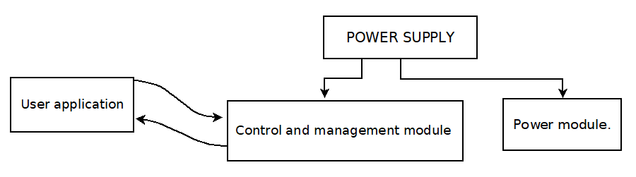
- Block diagram of the battery charging system.

Power module.
The design of the power module was structured in four main blocks:
- Type P current control system: Controls the load current by means of a non-inverting amplifier with adjustable gain. It uses a resistive current sensor with 0.5 Ω and 1 Ω resistors to measure small (up to 450 mA) and large (up to 2 A) currents, respectively. A MOSFET manages the power due to its thermal robustness.
- Load voltage amplifier: Raises the load voltage up to 22 V by means of a non-inverting amplifier with gain of 8. It includes short-circuit protection with constant current of 4 A and uses a Darlington transistor in the class B power circuit.
- Power circuit: Provides the current and voltage required for charging, incorporating short-circuit protection.
- Battery charging relays: Allow to select between low or high charge, disconnect the battery at shutdown and perform discharge tests. They are controlled by a BJT transistor and have indicator lights to show their status.
- User application. Two complementary applications have been developed. The first allows, via a mobile app, to configure the maximum battery voltage and monitor its charge status in real time. The second application is designed to view the charging curves stored on the system's SD card.

Control and management module
This module uses an ESP32 to manage the battery charging system, measure variables (temperature, humidity, voltage and current), store data on a microSD, and communicate with the user via Bluetooth. It also displays key information on an LCD screen.

Load control system: The ESP32 manages the power module and acts as a slave to the management system via UART communication. This system performs multitasking, including:
- Task 1: Load control, adjusting current and monitoring errors such as disconnected, damaged or overcurrent battery.
- Task 2: UART communication to receive the setpoint (maximum load voltage) and send data such as voltages, current and error codes.
- Task 3: Linearization of measured values (voltage and current) using polynomials adjusted and verified with CIE122 and UNI-T UT122 multimeters.

Conditioning circuit: LM358 operational amplifiers were used to condition signals:

- Current: Instrumentation amplifier with 5.45 gain and voltage follower.
- Voltages (battery and source): Resistive dividers with attenuations of 12.8X and 6.45X, respectively, connected to voltage followers to protect the ESP32.
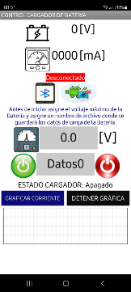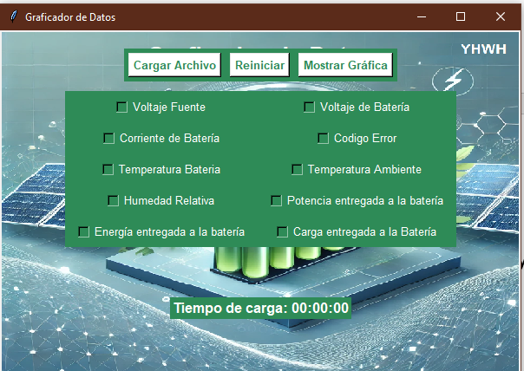
- User interface. Left: Interface for monitoring and controlling the charger. Right: Interface for data analysis.

Temperature and humidity sensors:

- DS18B20: For measuring battery temperature (±0.5°C error).
- DHT22: For measuring ambient temperature (±0.5°C) and humidity (±2% RH).

Wireless management and communication system: A second ESP32 performs five parallel tasks:
- Bluetooth communication with the user application to send and receive data.
- UART communication with the charging system to exchange data and manage microSD storage.
- Sensor reading (DHT22) with stabilization times.
- LCD data display (voltages, current, temperatures, humidity and charger status).
- System management, including temperature monitoring (>40°C) and data storage on microSD.
- Controls the charging current (up to 2A) based on the actual current measured by the system, without exceeding the maximum voltage set by the user through the interface. Automatically reduces the current if the battery voltage exceeds the set value and stops charging when the current drops below the minimum value set by the system

User interface: The user interface of the charging system was developed using two complementary environments: MIT App Inventor and Python (see Figure 2). The first application allows the user to monitor and control the battery charger in real time via Bluetooth communication with the ESP32 module. It includes graphic components such as labels to display voltage and current, buttons to connect and control the system, fields to enter the maximum charging voltage and the name of the log file, as well as the measured current graph. The second interface was developed in Python for analysis of the data stored in the charger's microSD memory. This tool allows the user to load log files, select the parameters of interest - voltage, current, temperature, power, relative humidity, energy and charging time - and view customized graphs using a button and checkbox based interface.

POWER SUPPLY.
The power supply used was the solar panel, with a power of 80W and a nominal voltage of 24V. The technical specifications of the solar panel model OS80P, has a nominal maximum power of 80W and a tolerance of ±5W.
Among the electrical parameters, an operating voltage at maximum power point (Vmp) of 17.78V and a corresponding current (Imp) of 4.50A. These characteristics are appropriate for powering the entire developed system. In addition, the open circuit voltage (Voc), which is 21.33V, and the short circuit current (Isc), with a value of 5.03A, are specified. In terms of operating characteristics, the panel has a nominal operating cell temperature (NOCT) of 45 ± 2°C and withstands an operating temperature range between -40°C and +85°C. It has a recommended maximum series fuse rating of 12A. It is rated in Class A application.

RESULTS OF THE BATTERY CHARGING PROCESS

Development of the battery charging system: It includes power and control modules. Figures 3, 4, 5, and 6 show the developed circuits

Load tests performed: Load tests were performed on different batteries, only the results of one of the tests will be shown.
Lead-acid batteries (N70):
- Manufacturer: TOYO 12N7B-3A. Capacity: 7Ah.
- Tests with solar panel.
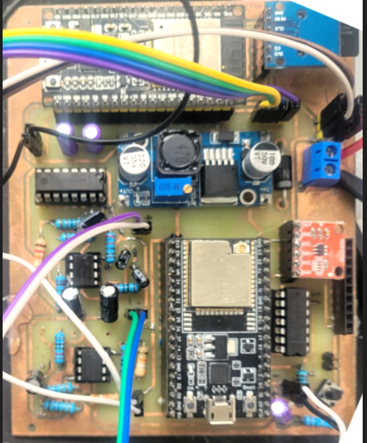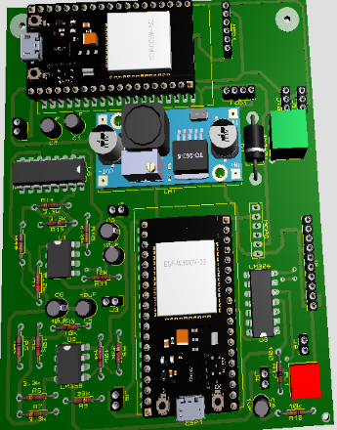
- Power module circuit developed..
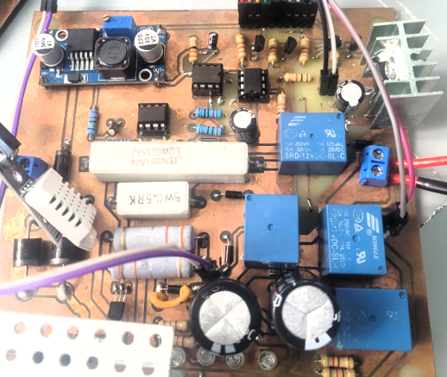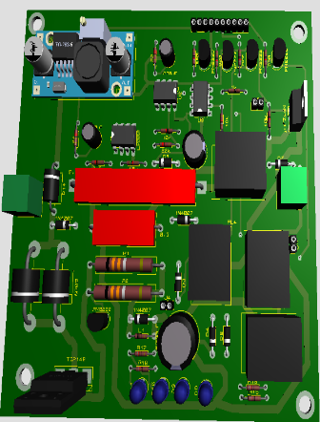
- Circuit of the control and management module developed.
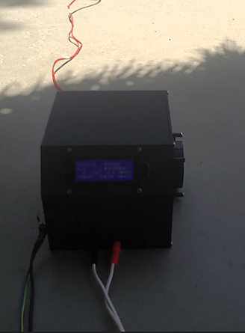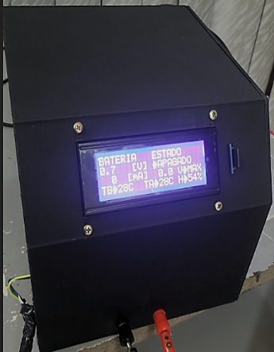
- Developed battery charge control system

Test results: The experimental tests of the solar charger were carried out in two contrasting scenarios in order to evaluate the behavior of the system under different solar irradiation conditions. The first scenario corresponded to a day with constant solar irradiation, i.e., without the presence of clouds; while the second one contemplated an environment with intermittent irradiation due to the presence of variable cloudiness. Both contexts made it possible to analyze the adaptive capacity of the charging system in situations of energy stability and fluctuation.
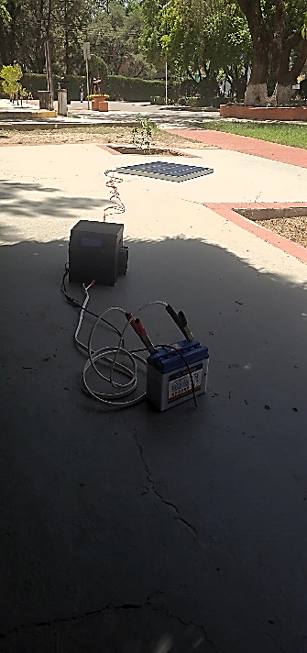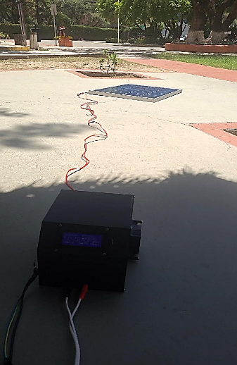
- Connecting the system to the solar panel and the TOYO battery, for the charging process using the solar energy generated by the solar panel.
Under continuous irradiation conditions, the initial voltage of the battery was at 11 V (see figure 7). At this stage, the system started the charging process with an ascending current ramp, starting from 0 mA until reaching a first threshold of 450 mA. The system constantly evaluates the state of the battery by measuring its voltage, comparing it with the charging voltage set by the user through the application. If the battery still requires more current input -inferred by the fact that it has not reached the setpoint voltage-, the system activates a second current level, raising the value from 0A to a maximum of 2000 mA. This transition is evident around second 50. Subsequently, the ramp continues its ascent to 2000 mA, while the battery voltage rises progressively until it reaches 13.5 V, the value set by the user. At around second 150, the current begins to gradually decrease in response to the increase of the battery voltage beyond the setpoint value. This behavior demonstrates that the system dynamically regulates the charging current in order to avoid overcharging, decreasing it as the battery reaches its optimum voltage level.
In terms of thermal behavior, the battery temperature did not exceed 25 °C during this test phase. As the charging current decreases, the temperature drops to 23 °C, which is one degree Celsius lower than the ambient temperature recorded at that time. This drop can be attributed to both the thermal properties of the battery material - which exhibits low heat retention - and environmental fluctuations caused by air currents, which is reflected in the ambient temperature curve. Overall, this thermal performance is evidence of an adequate control of the system to avoid overheating during the charging process.
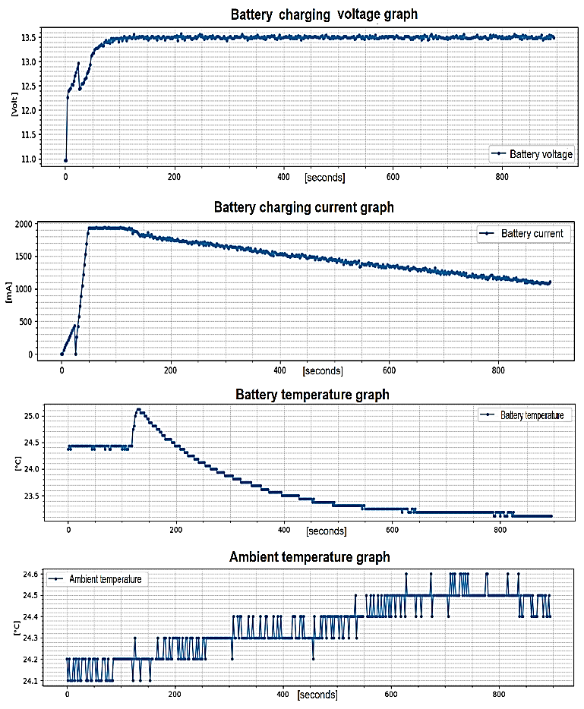
- Graphs corresponding to the system test during the charging of a 12V battery, under conditions of continuous solar irradiation and without interference
The second phase of testing was conducted under fluctuating irradiance conditions caused by intermittent clouds (see figure 8).. In this environment, the system response to variations in the maximum load voltage set by the user was also evaluated. During the first 350 seconds, the system operated with a maximum voltage value set at 14.4 V. Subsequently, this value was modified to 14.2 V for testing purposes, with the objective of observing the response of the controller to a new setpoint. Between seconds 550 and 670 there was a drop in irradiance caused by dense cloud cover, generating instability in the solar panel power supply. However, the system showed an adequate response to this variability, maintaining load stability. Between seconds 670 and 800, a new maximum charging voltage of 13.5 V was set. During this interval, the load current remained stable at approximately 180 mA. Upon reaching second 800, the system was shut down by the application in order to proceed with the review and analysis of the graphs stored in the SD memory of the device. It is worth mentioning that additional tests were performed using other types of batteries. However, these results are not included in this article due to the length that their detailed documentation would imply.

CONCLUSIONS
The analysis of the batteries (Lithium-Ion, Lithium-Polymer, Nickel-Cadmium and Lead-Acid) showed that the charging characteristics depend on their nominal voltage and capacity. Lithium-Ion and Lithium-Polymer batteries share a maximum voltage of 4.2 V per cell, while Nickel-Cadmium and Lead-Acid batteries are more robust under extreme conditions. Factors such as average standard charging current not exceeding 2A and temperature influence their efficiency and lifetime, with typical operating ranges from 0 °C to 45 °C, extended in specific models to -20 °C and 60 °.

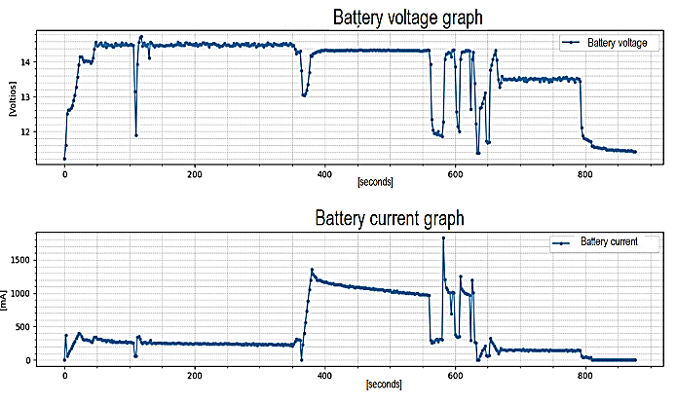
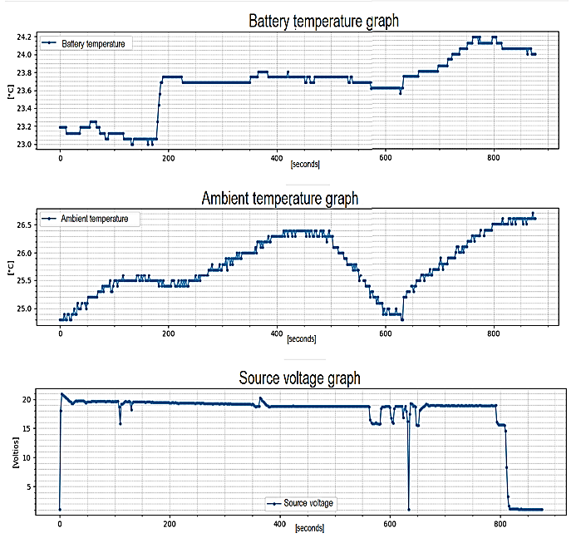
- Graphs corresponding to the system test during the charging of a 12V battery, under conditions of fluctuating and intermittent solar irradiation.
The designed charging system includes two ESP32 development boards, multitasking algorithms and a modular approach to hardware design, optimizing current with a MOSFET and P-type analog control system, and self-regulating voltage with BJT and operational amplifiers, resistive sensors and relays. The system has two thresholds of 450mA (for low current loads) and 2000mA (for high current loads), which adjusts the current with an algorithm similar to the multistage current charging method with an average error of less than 1% in measurements (thanks to the linearization of its values contrasting with readings of the CIE122 and UNI-T UT122 multimeters). The Bluetooth interface and an LCD display allow real-time monitoring, while the system detects and reports faults such as reverse polarity or over currents (maximum 4 A).
The results obtained with the 12 V battery show that the evaluated solar charging system responded in a stable and functional manner in both test scenarios, demonstrating adaptability to both constant conditions and variations in solar irradiation. The current regulation, the dynamic adjustment to changes in the voltage set by the user and the thermal monitoring without signs of overheating show an operational design with intelligent control principles in autonomous energy systems. The absence of system behavior failures, even during abrupt transitions in irradiance or setpoint changes, supports the validity of its performance under fluctuating or stable conditions.
Additionally, experimental tests were performed with other battery types, such as Li-ion (8800 mAh) and LiPo (7.4 V) batteries, obtaining efficient charging and minimal thermal variations (~25 °C). The project provides information on the battery charging curve so that it can be used as part of an initial diagnosis, as in the case of a test of a NiCd battery (700 mAh) in which it detected in less than 1 minute the possible aging in the battery, showing a rapid decrease in the charging current. However, the results of these tests are not included in this document for reasons of length.
A direct comparison with similar systems has not yet been made, as this project is in an early stage of development. Nevertheless, we have confidence in the reading of the measurements recorded by the system, because they were contrasted with readings of multimeters previously mentioned.
This charging system is particularly suited for IoT applications, where efficient energy management and adaptability to varying battery types are essential. The system’s ability to dynamically adjust parameters such as current and voltage makes it ideal for powering IoT devices, which often operate with rechargeable batteries like Li-Ion, LiPo, or NiCd. With its real-time monitoring capabilities, including Bluetooth connectivity and LCD display, this solution allows IoT systems to track battery health and charging status remotely. Additionally, the system’s versatility in supporting both low- and high-current loads ensures its suitability for a broad range of IoT devices, from low-power sensors to more power-demanding actuators, all while maintaining optimal performance and safety through integrated fault detection mechanisms.

References
[1] M. D. Yin, J. Cho, and D. J. E. Park, "Pulse-based fast battery IoT charger using dynamic frequency and duty control techniques based on multi-sensing of polarization curve," vol. 9, no. 3, p. 209, 2016.
[2] F. Lima et al., "A novel universal battery charger for NiCd, NiMH, Li-ion and Li-polymer," in ESSCIRC 2004-29th European Solid-State Circuits Conference (IEEE Cat. No. 03EX705), 2003, pp. 209-212: IEEE.
[3] D.-H. Kim, M.-S. Kim, K. Prabakar, and H.-J. J. E. Kim, "Efficient management of fast charging systems based on a real-time monitoring system," vol. 11, no. 4, p. 520, 2022.
[4] Y.-F. Luo, Y.-H. Liu, and S.-C. Wang, "Search for an optimal multistage charging pattern for lithium-ion batteries using the Taguchi approach," in TENCON 2009-2009 IEEE region 10 conference, 2009, pp. 1-5: IEEE.
[5] Samsung, "Introduction of INR18650-25R," 2024.
[6] T. Circuits, "Lithium Ion Cell 18650 2500mAh Battery Datasheet," 2024c.
[7] Tenergy, "TENERGY 18650 2200mAh Li-Ion Cell " 2024.
[8] A. P. P. Corp. (2024). This product specification describes product performance of 32700 6000mAh LiFePO4 battery. Available: https://batteryspace.com/prod-specs/11895.pdf?srsltid=AfmBOoqXYJs1qTjf6tOa1AXWzkZhxTCw_gYozIZvGFQe8_jh9JMiiFbx
[9] RS-PRO. (2024). Paquete de baterías recargables RS PRO de ión litio de 3,7 V, 2,6 Ah. Available: https://docs.rs-online.com/e888/A700000008874404.pdf
[10] Panasonic. (2024b). NICKEL CADMIUM BATTERIES: INDIVIDUAL DATA SHEET. Available: https://media.digikey.com/pdf/Data%20Sheets/Panasonic%20Batteries%20PDFS/P-120AAS.pdf
[11] Panasonic. (2024a). HHR210A. Available: https://api.pim.na.industrial.panasonic.com/file_stream/main/fileversion/3517
[12] F. Wat. (2024a). N300AAAJF. Available: http://www.fullwat.com/documentos/001290-LNK03789.pdf
[13] T. Circuits. (2024b). Li-ion Polymer 500mAh Battery Datasheet. Available: https://www.mouser.com/datasheet/2/855/ASR00035_500mAh-3078648.pdf?srsltid=AfmBOopjhVn6eromAwqHeZm42puCYYe3K02qsfhWL4vXrLZ50cD5UceO
[14] MIKROE. (2024). Li-Polymer battery datasheet SR674361P. Available: https://www.farnell.com/datasheets/2369105.pdf
[15] L. Battery. (2024a). LPC80500. Available: https://www.lipolbattery.com/LiPo-Battery-Datahseet/LiPo_Battery_LPC80500_3.7V_230mAh.pdf
[16] L. Battery. (2024b). LP604260. Available: https://www.lipolbattery.com/LiPo-Battery-Datahseet/LiPo_Battery_LP604260_3.7V_2000mAh.pdf
[17] L. Battery. (2024c). LP505563. Available: https://www.lipolbattery.com/LiPo-Battery-Datahseet/LiPo_Battery_LP505563_3.7V_2000mah.pdf
[18] L. Battery. (2024d). LPC80500. Available: https://www.lipolbattery.com/LiPo-Battery-Datahseet/LiPo_Battery_LPC80500_3.7V_230mAh.pdf
[19] L. Battery. (2024e). LP923438. Available: https://www.lipolbattery.com/LiPo-Battery-Datahseet/LiPo_Battery_LP923438_3.7V_1200mAh.pdf
[20] L. Battery. (2024f). LP7852115. Available: https://www.lipolbattery.com/LiPo-Battery-Datahseet/LiPo_Battery_LP7852115_3.7V_5000mAh.pdf
[21] L. Battery. (2024g). LP244147. Available: https://www.lipolbattery.com/LiPo-Battery-Datahseet/LiPo_Battery_LP244147_3.7V_520mAh.pdf
[22] L. Battery, "LPHD7424037," 2024h.
[23] L. Battery. (2024i). LPR653929. Available: https://www.lipolbattery.com/LiPo-Battery-Datahseet/LiPo_Battery_LPR653929_3.7V_665mAh.pdf
[24] L. Battery. (2024o). LP8873129. Available: https://www.lipolbattery.com/LiPo-Battery-Datahseet/LiPo_Battery_LP8873129_3S2P_11.1V_20Ah.pdf
[25] L. Battery, "LP526793," 2024n.
[26] Yuasa, "Yuasa 12N7-4A - Convencional 12 Volt Batería," 2024.
[27] G. Industronic. (2024). BPA-12V38Ah. Available: https://grupoindustronic.com/producto/baterias-ups-de-plomo-acido-12v38ah/
[28] Motoma, "batería de plomo-ácido SLA VRLA OPzV 2V 1000Ah," 2024.
[29] EverExceed. (2024). BATERIA DE ACIDO PLOMO RECARGABLE SELLADA DE 12V12AH. Available: https://dicor.com.bo/baterias-secas-12v12ah/
[30] VARTA. (2024). VARTA POWESSPORTS AGM. Available: https://www.varta-automotive.com/
[31] Exide. (2024). YTX20L-BS. Available: https://www.exide.com/
[32] M. POWERED. (2024). MK Powered M45-12 SLD M | Bateria 12V 45Ah Serie AGM. Available: https://mejorbaterias.com/mk-powered-M40-12-SLD-M-1896.html?gad_source=1&gclid=Cj0KCQiAsOq6BhDuARIsAGQ4-ziFm7iaVR-LA5dvjvVabf21cleg3gjLMQfQORSjT0pJB4rNHmbp_EQaAsIjEALw_wcB

