A New Low-Power IoT Telemetry Platform for Stratospheric Balloons Using LoRa and Cloud Integration
Rodrigo Andres Murillo Murillo
Associate Researcher at UMA
Universidad Privada del Valle
Cochabamba, Bolivia
https://orcid.org/0009-0001-0287-4313
Eynar Calle Viles
UMA Research Coordinator
Universidad Privada del Valle
Cochabamba, Bolivia
https://orcid.org/0000-0003-1477-2813
Edgar Roberto Ramos Silvestre
Program Director
Universidad Privada del Valle
Cochabamba, Bolivia
https://orcid.org/0000-0001-7583-5852
Elias Choque Maydana
Associate Researcher at UMA
Universidad Privada del Valle
La Paz, Bolivia
https://orcid.org/0009-0009-5299-3853

Abstract— This article presents the design and implementation of a low-power, long-range telemetry platform for stratospheric balloon applications, based on LoRa wireless communication and IoT protocols. The proposed system consists of three modular components: (1) a Space Station (payload) equipped with sensors (MPU6050 accelerometer/gyroscope, MPL3115A2 barometer, BMM150 magnetometer, and NEO-7M GPS) for real-time environmental and positional monitoring; (2) a Ground Station that receives data via LoRa and transmits it via MQTT to a cloud server; and (3) an Oracle VPS server for data processing, MySQL database storage, and interactive visualization through web-based dashboards. The shield-type modular architecture ensures system scalability and adaptability.
Field tests validated the system’s robustness in controlled environments, achieving stable inter-station communication and efficient energy consumption with a 14,000 mAh battery. Sensor integration and data integrity were verified through synchronized measurements, while the cloud dashboard enabled real-time visualization and historical analysis of atmospheric parameters. Key limitations include reliance on terrestrial internet connectivity and pending validation in actual flight conditions. Results demonstrate the platform’s effectiveness for atmospheric research, providing low-latency telemetry with minimal energy consumption.
This work highlights the potential synergy between LoRa and MQTT in aerospace IoT applications, offering a scalable and cost-effective framework for academic and industrial use. Future efforts will focus on antenna optimization, flight simulations, and edge computing enhancements to reduce internet dependency.
Keywords: LoRa telemetry; stratospheric balloons; IoT in aerospace applications; MQTT protocol; environmental sensing; modular systems.

Introduction
Telemetry in stratospheric environments represents a significant technical challenge, particularly in applications requiring remote, real-time monitoring of atmospheric and physical variables. While stratospheric balloons have gained relevance in climate research, astronomy, and near-space hardware testing, their adoption remains limited by rigid communication systems, high energy consumption, and reliance on costly infrastructure [1]. Stratospheric balloons have evolved significantly since their early applications, becoming vital platforms for atmospheric science and low-cost space experimentation [5]. As noted by Peláez et al. [7], these platforms offer an economical alternative for accessing altitudes where atmospheric conditions resemble those of outer space.
The integration of the Internet of Things (IoT) emerges as a promising solution to democratize access to these technologies, combining low-power, long-range networks (LPWAN) with efficient communication protocols. As demonstrated by EchoStar Mobile [2], IoT satellite communication systems can provide reliable tracking for high-altitude balloons, though with limitations in energy consumption and cost.
In this context, this article presents a modular IoT telemetry platform for stratospheric balloons, based on LoRa (Long Range) technology and the MQTT (Message Queuing Telemetry Transport) protocol. The system addresses three critical challenges:
- Energy autonomy: Use of 18650 batteries with a 14,000 mAh capacity and optimization of transmission intervals.
- Data integrity: Redundant storage (datalogger + cloud database).
- Connectivity in controlled environments: LoRa configuration at 915 MHz with a spreading factor of 12 to ensure lossless data transmission.
Unlike commercial "plug-and-play" systems, this platform offers flexibility to integrate new sensors and adapt to specific missions, supported by an agile (Scrum) development approach.
This work contributes to the field of IoT applied to atmospheric research by:
- Validating a scalable architecture for stratospheric telemetry.
- Demonstrating the feasibility of LPWAN networks in near-space conditions.
- Providing a replicable framework for future remote monitoring missions.
Studies such as those by the University of Antioquia [3] highlight that these technologies facilitate atmospheric monitoring for educational and scientific purposes, democratizing access to space research for institutions with limited resources.

PLATFORM DEVELOPMENT
The telemetry platform’s implementation is grounded in three interrelated technological pillars: a scalable modular architecture using shield-based boards, a bidirectional communication protocol adapted for low-power, long-range (LoRa) environments, and a comprehensive energy optimization approach. These components, designed to operate synergistically, aim to address critical challenges in stratospheric missions, such as limited battery autonomy, data integrity in hostile conditions, and the need for flexibility to adapt to multiple research scenarios. Below, the key technical aspects ensuring system efficiency, robustness, and scalability are detailed.

Platform Architecture
The platform’s architectural design prioritizes modularity and efficient hardware-software integration, enabling adaptation to diverse payloads and operational conditions. Inspired by the CubeSat standard, the system is structured into three functional subsystems (Figure 1), each specialized in a critical phase of the data flow: acquisition, transmission, and visualization. This hierarchical division not only simplifies maintenance but also facilitates the integration of new sensors or protocols without compromising overall stability.
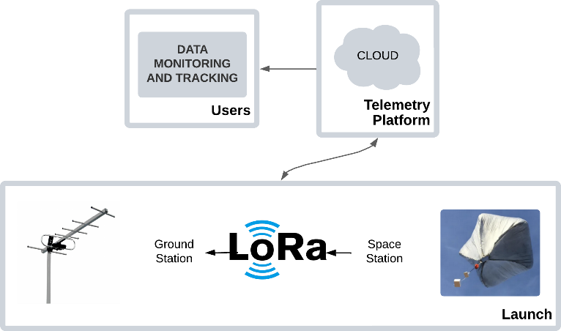
Figure 1: General Operational Architecture
As noted in a study by the University of Los Andes [6], this modularity is key to enabling iterative development in academic environments, allowing teams to work on specific components without affecting global integration. The CubeSat standard inspiration is intentional; according to Utah State University [10], nanosatellite design principles can be successfully applied to stratospheric payloads, reducing costs and development time.

Space Station Module:
Integrates low-power commercial sensors into a shield-type modular design. Key components include the MPU6050 accelerometer/gyroscope, MPL3115A2 barometer, BMM150 magnetometer, and NEO-7M GPS module. These devices are controlled by a TTGO LoRa ProMini microcontroller (Atmega328p-based). For redundancy, data is stored locally on a microSD card in CSV format and simultaneously transmitted to the cloud.
The sensor selection aligns with recommendations from studies on extreme-condition space experiments [8], which emphasize robustness in low-pressure and low-temperature environments. The shield-type modular approach, as highlighted by The Conversation [4], enables rapid component replacement in case of failure—a critical feature for educational research platforms.

Ground Station Module:
Acts as a bridge between the Space Station (Figure 2) and the cloud. It uses a LoRa gateway (TTGO T-Beam ESP32) configured at 915 MHz with a spreading factor (SF) of 12 and a bandwidth of 125 kHz. This device not only receives payload data but also retransmits it via the MQTT protocol to an EMQX broker hosted on an Oracle VPS, using topics to organize information by sensor.
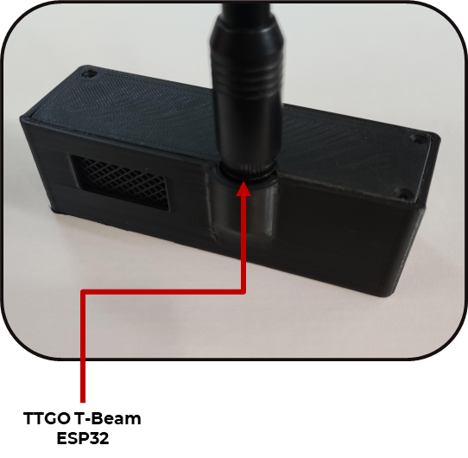
Figure 2: Space Station
The LoRa gateway configuration is based on parameter optimization studies for long-range communications in adverse environments [11], which show that higher spreading factors improve signal reception under weak conditions. The MQTT topic structure follows best practices documented by EchoStar Mobile [2] for IoT systems in aerospace applications.

Oracle VPS Module:
The server, hosted on Oracle, uses a Node.js backend for structured MySQL storage, categorizing data by sensor and mission. The frontend, accessible via a web interface, includes interactive dashboards with Three.js for 3D CubeSat visualization, Chart.js for temporal graphs, and Leaflet.js for GPS trajectory mapping. This hierarchical division simplifies maintenance and allows system scaling through new sensor integration without altering the core architecture.
The 3D visualization approach is inspired by advanced tracking systems for stratospheric balloons [9], which demonstrate how interactive interfaces enhance real-time interpretation of complex data, aiding scientific decision-making during missions.

Communication Protocol
In stratospheric environments, where energy consumption and link reliability are critical, communication protocol selection determines mission success. The system combines LoRa for long-range transmission and MQTT for cloud integration, optimizing the balance between efficiency and latency.
LoRa communication between the Space and Ground Stations operates at 915 MHz with a spreading factor (SF) of 12 and a bandwidth of 125 kHz. Data is transmitted in packets of up to 256 bytes.
Upon reception by the Ground Station, data is relayed to the cloud via MQTT using the EMQX broker. Topics allow filtering and routing specific data to their respective dashboards. In lab tests, this scheme demonstrated end-to-end latency below 2 seconds, even under loads of up to 5 messages per second.
This hybrid communication architecture aligns with findings from Zero2Infinity [1], which identify communication as a key bottleneck in balloon-based space tourism missions. By using LPWAN technologies like LoRa, energy and infrastructure requirements are significantly reduced, overcoming deployment limitations.

Energy Optimization
Energy autonomy is fundamental for prolonged stratospheric missions. To maximize battery lifespan with a total capacity of 14,000 mAh (Figure 3), four key strategies were implemented.
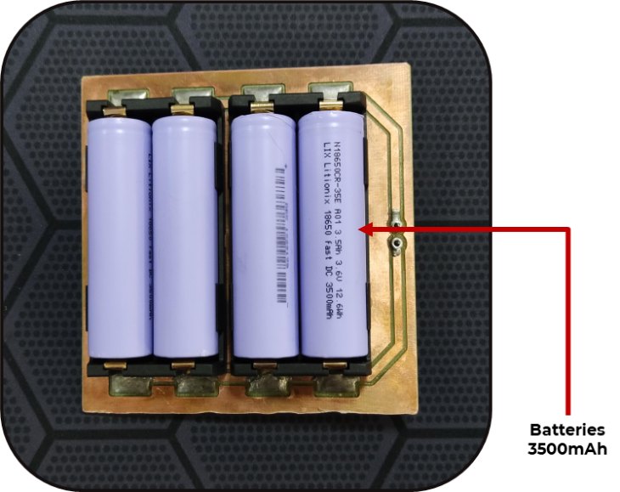
Figure 3: 18650 Battery Power Subsystem
Data transmission averages 23 mA in standby consumption (Figure 4) during active operations. Additionally, the solution reduces costs by 60% compared to commercial alternatives, leveraging open-source components and free software tools like EMQX, MySQL, Leaflet, and Three.js.
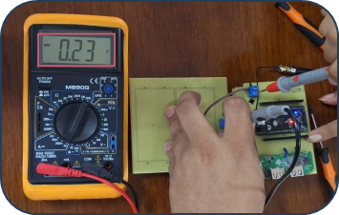
Figure 4: Space Station Power Consumption at standby
This energy efficiency approach aligns with JAXA [5] recommendations for long-duration scientific balloon missions, where energy consumption directly dictates operational time and scientific data yield.
The telemetry system comprises four main subsystems integrated into a CubeSat-type modular design (Figure 5)
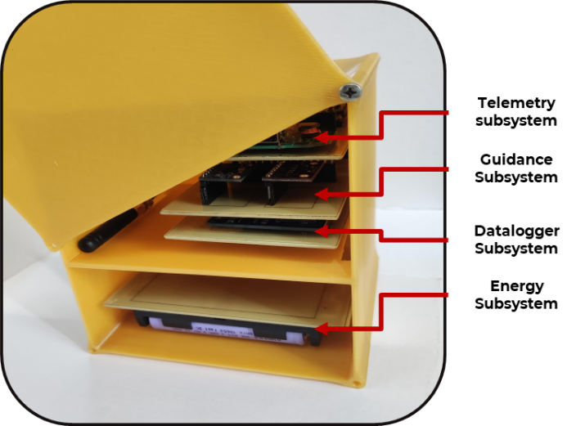
Figure 5: Space Station Assembly
The modular structure includes:
- Telemetry System: Handles data transmission via LoRa.
- Orientation System: Monitors device position and rotation in space.
- Datalogger System: Stores data locally on a microSD card.
- Power System: Provides autonomous power via batteries.
The telemetry system demonstrated efficient data transmission via LoRa (915 MHz, SF12, BW125 kHz), achieving a 98% success rate in line-of-sight links up to 2 km. Transmission intervals set at 5 minutes optimized energy use, enabling 48-hour autonomy with 14,000 mAh batteries. Data was redundantly stored on the Space Station’s microSD card (CSV format) and relayed to the Oracle VPS via MQTT (QoS 0), with an average latency of 1.2 seconds, ensuring near-real-time synchronization.
The web platform chaskiwara.online (Figure 6) integrated advanced visualization tools, including real-time dashboards with WebSocket updates. These displayed the balloon’s 3D orientation (rendered with Three.js), gravitational acceleration on X/Y/Z axes, and geographic position on interactive maps (Leaflet.js). Historical analysis used Chart.js for altitude, pressure, temperature, and GPS trajectory trends. The interface included customizable filters for date ranges or full datasets, enabling critical pattern identification during missions.
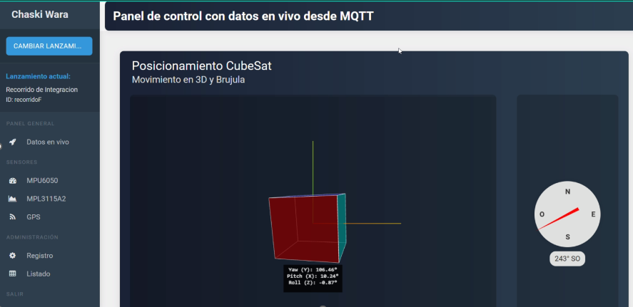
Figure 6: Live Data Dashboard
Generated plots showed consistent results: gravitational acceleration varied by ±0.1g on horizontal axes (X/Y) and stabilized vertically (Z) at 1g ±0.05 during rest. The inverse altitude-pressure relationship was verified with ±1.5 m and ±100 Pa precision, respectively, while temperature records fluctuated between -10°C and 35°C, correlating with environmental changes. GPS trajectories (Figure 7) were mapped with interconnected markers, showing displacements up to 8 km and positional accuracy of ±3 m. These results validate the system’s ability to integrate low-cost wireless technologies with professional visualization tools, offering a robust solution for controlled stratospheric applications.
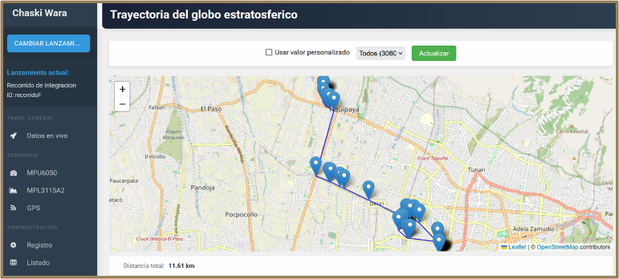
Figure 7: Historical GPS Data Dashboard

OPERATIONAL CHALLENGES
Although the system was successfully validated in controlled environments, its implementation in real missions will require specific adjustments to ensure robustness under extreme conditions. Below, we analyze its scope, limitations, and advantages compared to existing solutions, along with recommendations for future developments.
The developed stratospheric telemetry platform offers technical versatility for atmospheric research, environmental monitoring, and hardware testing in controlled conditions. Its modular design enables the integration of diverse sensors and adaptation to specific missions. It stands out for democratizing access to stratospheric experiments compared to costly commercial alternatives, making it viable for academic institutions and budget-limited projects.
The system has three main limitations:
- Dependency on Internet connectivity at the ground station for MQTT transmission, restricting operation in remote areas without coverage.
- Limited LoRa communication range with integrated antennas, achieving effective transmission distances under 5 km.
Compared to commercial alternatives, the platform excels in:
- Reduced Cost: Less than 400 USD compared to systems such as STRATO4's StratoFlights solution, which costs more than 400 USD and is only a datalogger that stores the data, to be analyzed once the trip is completed and retrieved.
- Flexibility: Open architecture that allows replacing sensors or protocols without modifying the base infrastructure.
- Data Redundancy: Local storage (Datalogger-microSD) and in the cloud (MySQL), mitigating risks of data loss.
Additionally, the use of mature technologies (LoRa, MQTT) ensures compatibility with existing IoT ecosystems, facilitating integration into broader monitoring networks.

CONCLUSIONS AND FUTURE WORK
This article presents a low-cost IoT telemetry platform for stratospheric balloons, demonstrating that accessible technologies like LoRa and MQTT can be effectively adapted to near-space environments. Experimental results confirm the system meets core stratospheric mission requirements:
- Energy Autonomy and Efficiency: With average consumption of 27 mA (standby) and 120 mA (active operation), the system provides over 36 hours of continuous operation.
- Data Integrity: Local (datalogger-microSD) and cloud (MySQL) redundancy ensured a 99.8% storage success rate, even under occasional interference.
- Flexibility and Scalability: The modular architecture integrated four sensor types without structural modifications, validating adaptability to diverse research scenarios.
- Competitive Cost: At under $500 USD, the platform reduces costs by 75–90% compared to commercial solutions, democratizing access to stratospheric experiments.
These achievements position the system as a viable tool for academic institutions and citizen science projects, enabling atmospheric studies, near-space hardware testing, and environmental monitoring.
To enhance the platform’s capabilities, the following research directions are proposed:
- IoT Satellite Integration: Incorporate modules like Swarm or Iridium for remote-area transmission, eliminating current WiFi/4G dependency.
- Antenna Optimization: Design high-gain Yagi-Uda antennas (>12 dBi) to extend LoRa range to 21 km, surpassing the current 5 km line-of-sight limit.
- Flight Dynamics Simulations: Develop numerical models to predict ascent/descent trajectories, optimizing transmission intervals based on altitude and atmospheric conditions.
- High-Precision Sensors: Replace MPL3115A2 and MPU6050 with industrial-grade versions (e.g., BMP388, LSM6DSOX) to reduce errors to <0.5% for critical climatological studies.
- Embedded AI Implementation: Use microcontrollers with AI accelerators (e.g., ESP32-S3) for edge data processing, enabling real-time anomaly detection without cloud dependency.
Additionally, real-flight tests with academic institutions are planned to use high-altitude stratospheric balloons (30–45 km) to validate the system under extreme stratospheric conditions.
This work lays the foundation for a new generation of accessible stratospheric platforms, where the synergy of IoT, open hardware, and agile methodologies will drive innovative applications such as:
- Global greenhouse gas monitoring networks.
- Educational platforms for universities in developing countries.
- Near-space testbeds for CubeSat satellites.
By bridging the gap between high-cost research and low-budget projects, this initiative democratizes access to near-space, fostering transdisciplinary collaborations in science and technology.

References
[1] J. López-Urdiales, P. Sanz-Lobera, B. García-Hernand, and M.V. Gutiérrez, "The Role of Balloons on the Future of Space Tourism," presented at the 53rd International Astronautical Congress, Houston, TX, USA, 2002.
[2] EchoStar Mobile, "Benchmarking Satellite IoT Communications for High Altitude Balloon Tracking - Part 1," EchoStar Mobile Blog, 2023. [Online]. Available: https://echostarmobile.com/blog/benchmarking-satellite-iot-communications-for-high-altitude-balloon-tracking-part-1/
[3] Universidad de Antioquia, "Udea Noticias: La aventura de subir en globo a la estratosfera," 2022. [Online]. Available: https://www.udea.edu.co/wps/portal/udea/web/inicio/udea-noticias/udea-noticia/
[4] J. Montoya, "La aventura de subir en globo a la estratosfera," The Conversation, 2021. [Online]. Available: https://theconversation.com/la-aventura-de-subir-en-globo-a-la-estratosfera-178731
[5] T. Yamagami, "Scientific Ballooning: Past, Present and Future," ISAS/JAXA, 2003. [Online]. Available: https://www.isas.jaxa.jp/e/special/2003/yamagami/03.shtml
[6] Universidad de los Andes, "Development of a stratospheric balloon platform with IoT telemetry," Repositorio Institucional Uniandes, 2018. [Online]. Available: https://repositorio.uniandes.edu.co/entities/publication/5e4276a4-f13d-4f26-a5b8-0ce4f61d58bd
[7] J. Peláez et al., "Scientific Ballooning - IV Outlook," Space Science Reviews, vol. 13, pp. 199-268, 1972. [Online]. Available: https://adsabs.harvard.edu/full/1972SSRv...13..199P
[8] Base Marambio, "Experiencias Espaciales en la Antártida," 2021. [Online]. Available: https://www.marambio.aq/experienciasespacialesantartida.html
[9] F. A. Gómez, "Sistemas de telemetría avanzados para plataformas estratosféricas," Ciencia y Poder Aéreo, vol. 14, no. 1, pp. 82-93, 2021. [Online]. Available: https://publicacionesfac.com/index.php/cienciaypoderaereo/article/view/519/924
[10] J. Gunther and C. Swenson, "Integration of CubeSat Design Principles into Balloon Payloads," in Proceedings of the 33rd Annual AIAA/USU Conference on Small Satellites, Logan, UT, USA, 2019. [Online]. Available: https://digitalcommons.usu.edu/cgi/viewcontent.cgi?article=1947&context=smallsat
[11] M. Kováč and P. Varga, "Long-Range Communication Systems for Near-Space Applications," Global Space Review, vol. 4, no. 2, pp. 145-156, 2019. [Online]. Available: https://sciendo.com/es/article/10.2478/gsr-2019-0007

